  - OBJECT-ORIENTED PROGRAMMING (EEC 2211)

Decentralized Microgrid Simulation and Optimization System
PROJECT DONE BY:
NAME: MOSES OMONDI NALO
REG NO: ENE212-0075/2024
COURSE: BSc. ELECTRONIC AND COMPUTER ENGINEERING

THE UNIQUE-GOLDEN COMMUNITY

Table of Contents
Background 1
System Objectives 1
Requirements Specification 1
Functional Requirements 1
Non-Functional Requirements 1
System Architecture 2
Overview 2
Major Architectural Components 2
System Architecture Diagram 3
Component Explanation 3
System Design (Class Definitions) 4
Object-Oriented Hierarchy 4
Core Data Structures 4
Implementation Details: Core Algorithms 4
Energy Generation Mathematics 4
Load Shedding Protocol (Emergency Handling) 4
Data Storage Strategy (File Formats) 4
Conclusion 5
Appendix: Operation Screenshots 6

Table of Figures
Figure 1 Operator Login Window 6
Figure 2 Dashboard (Main Menu) 6
Figure 3 Assets Management 7
Figure 4 Load Management 7
Figure 5 Smart Allocation and Load Shedding Simulation 8
Figure 6 Operator Logout and Session Persistence 8

Background
The transition toward renewable energy has necessitated the development of decentralized power systems known as microgrids. These grids often operate autonomously, relying on intermittent energy sources such as solar and wind. The primary engineering challenge in managing a microgrid is maintaining real-time equilibrium between power generation, energy storage, and consumer demand.

This project is an Energy Management System (EMS) terminal application developed to simulate, monitor, and optimize an isolated microgrid. Built using C++, the system leverages Object-Oriented Programming (OOP) principles to model physical energy assets and consumer loads mathematically. It serves as a practical engineering tool to predict grid behaviour under varying environmental conditions and to execute autonomous load-shedding protocols during critical power deficits.

System Objectives
- Modelling: Accurately simulate the power output of renewable energy sources using mathematical efficiency models based on environmental variables (irradiance, temperature, wind speed).
- Management: Provide a secure, persistent interface for a grid operator to add, remove, and toggle physical assets and consumer loads.
- Optimization: Implement a robust load-shedding algorithm that autonomously disconnects non-essential loads to preserve grid stability during low-power emergencies.

Requirements Specification

Functional Requirements
Functional requirements define the specific behaviours and capabilities the system must support.
- Session Management: The system must require an operator ID for access to prevent unauthorized grid modifications.
- Asset Management: The user must be able to create, remove, and toggle the operational status (online/offline) of Energy Assets (Solar Arrays, Wind Turbines).
- Load Management: The user must be able to register, remove, and toggle consumer loads, assigning each a priority level from 1 (lowest) to 10 (highest).
- Environmental Simulation: The system must accept manual inputs for solar irradiance, ambient temperature, and wind speed to run a simulation step.
- Grid Balancing: The system must automatically calculate total generation, charge/discharge the battery, and supply loads.
- Autonomous Load Shedding: If demand exceeds generation and storage, the system must shed loads sequentially starting from the lowest priority until stability is restored.
- Data Persistence: The system must serialize and save the state of all assets and loads to local .csv files and reload them upon system startup.

Non-Functional Requirements
Non-functional requirements specify system attributes such as performance, usability, and reliability.
- Reliability (Exception Handling): The system must not crash under unstable grid conditions; it must throw and catch a custom InsufficientPowerException to safely trigger recovery protocols.
- Usability (Input Validation): The terminal interface must reject invalid data types (e.g., letters instead of numbers) and restrict inputs to realistic engineering ranges to guide non-expert users.
- Maintainability (OOP Design): The system architecture must use encapsulation, inheritance, and polymorphism to allow for future integration of new energy sources (e.g., Hydroelectric) without modifying the core control logic.
- Performance: Simulation steps and sorting algorithms must execute in real-time.

System Architecture

Overview
The software architecture follows a simplified Model-View-Controller (MVC) pattern adapted for a Command Line Interface (CLI). This separation of concerns ensures that the physical grid logic (Domain Layer) is entirely isolated from the user menus (UI Layer) and the file storage mechanisms (Data Layer).

Major Architectural Components
- Application Layer (Controller & View): Handles the main execution loop, user authentication, menu routing, input validation, and rendering formatted ASCII dashboards.
- Control Center (Service Layer): The central orchestrator. It manages the collections of assets and loads, handles the battery state, and executes the core balancing and load-shedding algorithms.
- Domain Models (The Physics): The C++ classes representing the physical entities (SolarArray, WindTurbine, Battery, Load). These contain the engineering mathematics and state logic.
- Data Access Layer: File I/O streams embedded within the ControlCenter that read and write serialized object data to external CSV files.

System Architecture Diagram

User Interface
- Terminal Output
- Dashboards
- Menus

Application Controller
- Session Management
- Menu Routing
- Execution Loop

Control Center
- Grid Balancing Algorithm
- Load Shedding Protocol
- Exception Handling

Data Layer (I/O)
CSV Files
- energy_assets.csv
- consumer_loads.csv

Component Explanation
- Application: Acts as the entry point. It captures operator inputs and translates them into commands for the ControlCenter.
- ControlCenter: Holds vectors of pointers to PowerSource objects and vectors of Load structs. It is responsible for calling calculatePower() polymorphically across all assets during a simulation step.
- PowerSource (Abstract): Enforces a contract that all energy generators must have a calculatePower and serialize method, allowing the system to scale easily.
- CSV Storage: Acts as a lightweight database. Using std::ifstream and std::ofstream, the system translates object attributes into comma-separated strings for persistent memory

System Design (Class Definitions)

Object-Oriented Hierarchy
- Base Class: PowerSource
  - Attributes: string assetId, bool isOnline
  - Methods: virtual calculatePower() = 0, virtual serialize() = 0, toggleStatus()
- Derived Class: SolarArray
  - Attributes: double P_max, double alpha (Temperature Coefficient)
  - Methods: Overrides calculatePower() utilizing irradiance and temperature variables.
- Derived Class: WindTurbine
  - Attributes: double efficiency, double rotorArea
  - Methods: Overrides calculatePower() utilizing wind speed variables and safety cutoff logic.

Core Data Structures
- std::vector<PowerSource*>: Used to store heterogeneous energy assets. Pointers are required to enable polymorphic behaviour.
- std::vector<Load>: Used to store consumers. A standard vector is used to allow the operator to access and manage specific loads by index via the UI.
- std::sort() Algorithm: Utilized during emergencies. It sorts the load vector using a custom static comparator to ensure High-Priority loads are processed first.

Implementation Details: Core Algorithms

Energy Generation Mathematics
The system translates physics into code. For example, the Solar Array power output is calculated using the standard temperature-corrected formula: output = P_max * (irradiance / 1000.0) * (1 + alpha * (temp - 25.0))

Load Shedding Protocol (Emergency Handling)
When total demand exceeds the sum of generated power and available battery charge, normal execution is halted via a thrown Exception. The triggerLoadShedding method executes the following logic:
- Sort: Active loads are sorted in descending order of priority.
- Greedy Allocation: The algorithm iterates through the sorted list, assigning power to loads.
- Shedding: Once available power hits zero, remaining loads have their isConnected status set to false, effectively blacking them out to save the overall grid.
- Persistence: The new, degraded grid state is immediately saved to the disk.

Data Storage Strategy (File Formats)
The application relies on custom serialization.
energy_assets.csv Format: [AssetType],[AssetID],[Parameter1],[Parameter2]
- Example (Solar): Solar,PV-01,300.0,-0.004
- Example (Wind): Wind,WT-01,0.4,50.0
consumer_loads.csv Format: [LoadName],[PowerDemand],[Priority],[IsConnected_Boolean]
- Example: City Hospital,120.0,10,1
- Example: Streetlights,40.0,2,0

Conclusion
The Decentralized Microgrid Simulation System successfully fulfills the objectives of the EEC 2212 Object-Oriented Programming course. By heavily utilizing abstraction, polymorphism, file I/O, and exception handling, the project provides a robust, interactive engineering tool. The system's modular architecture guarantees that it mimics real-world Energy Management System software, proving capable of persisting data and making autonomous, mathematically sound decisions during grid instability.

Appendix: Operation Screenshots

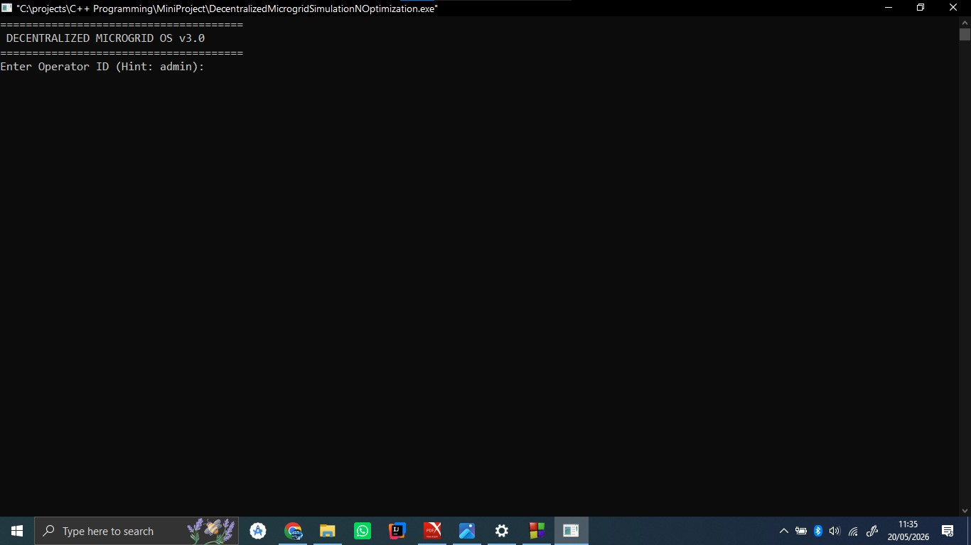
Figure 1 Operator Login Window
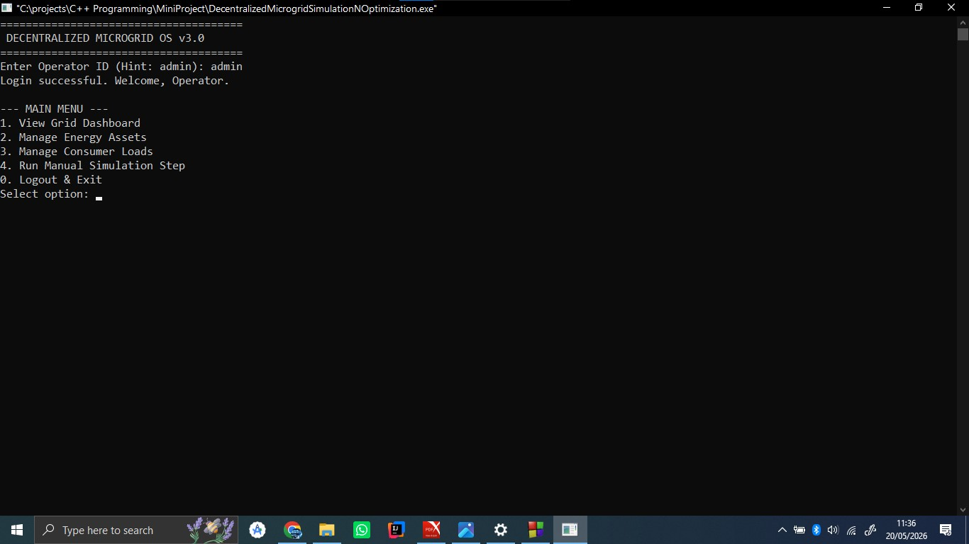
Figure 2 Dashboard (Main Menu)

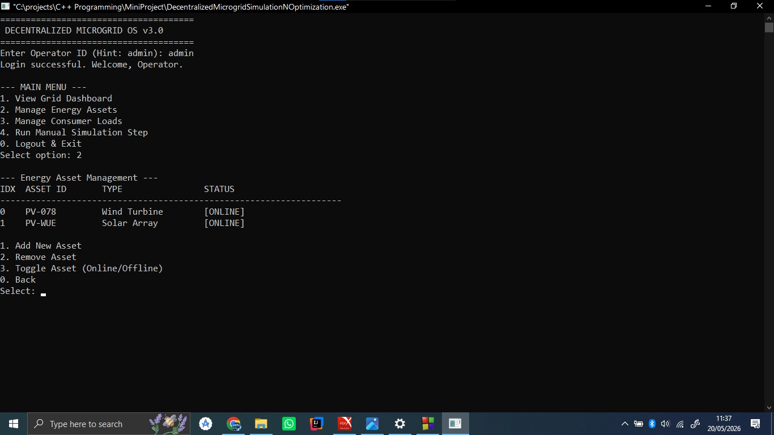
Figure 3 Assets Management

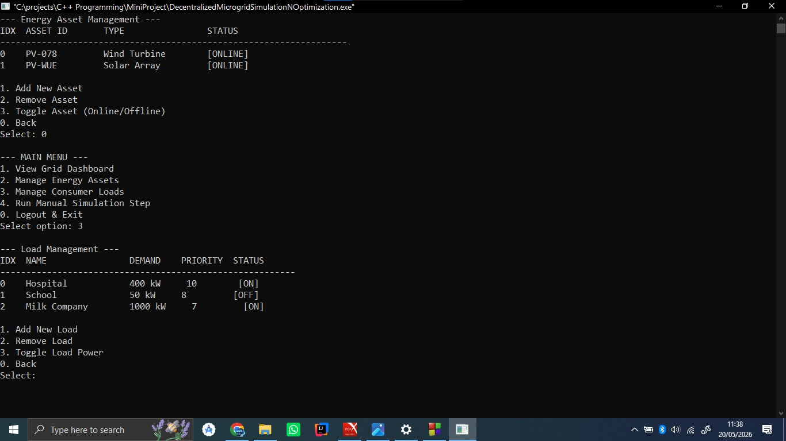
Figure 4 Load Management

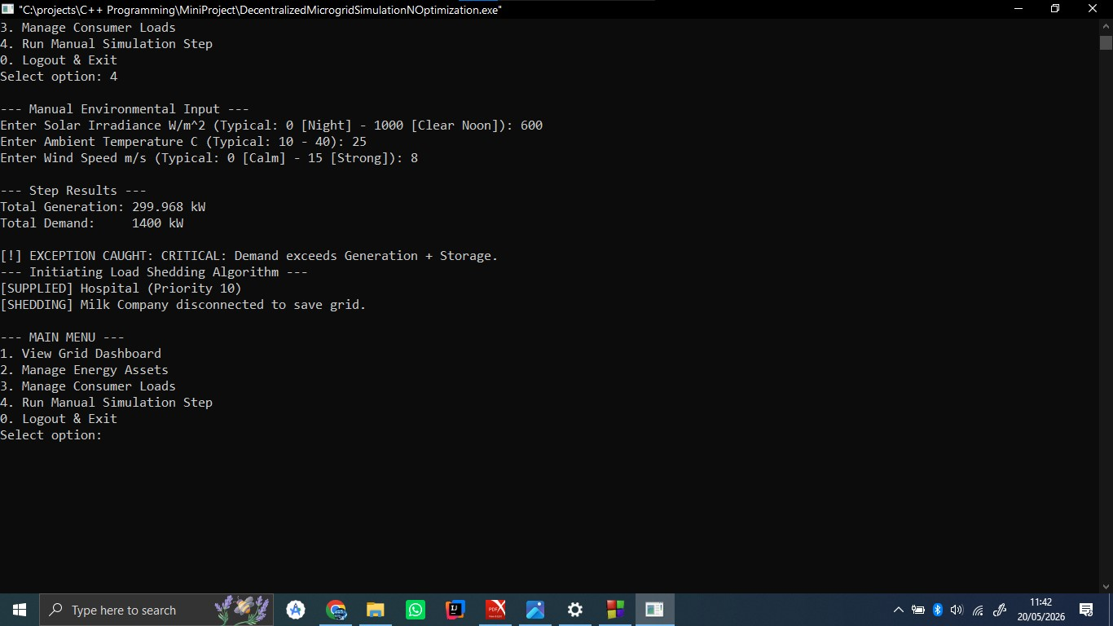
Figure 5 Smart Allocation and Load Shedding Simulation
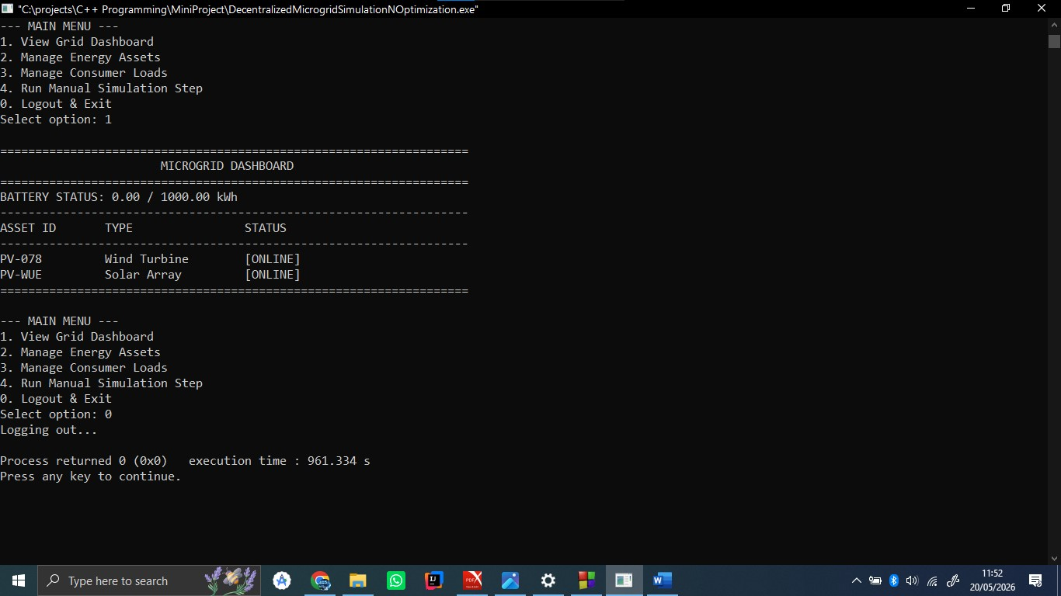
Figure 6 Operator Logout and Session Persistence

